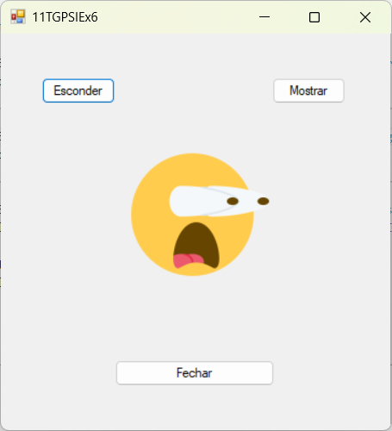

Public Class Form1

Private Sub ButtonEsconder_Click(sender As Object, e As EventArgs) Handles ButtonEsconder.Click
PictureBox1.Visible = False
End Sub

Private Sub ButtonMostrar_Click(sender As Object, e As EventArgs) Handles ButtonMostrar.Click
PictureBox1.Visible = True
End Sub

Private Sub ButtonFechar_Click(sender As Object, e As EventArgs) Handles ButtonFechar.Click
Dim result = MessageBox.Show("Deseja Mesmo Sair?", "11TGPSIEx3", MessageBoxButtons.OKCancel)

If result = DialogResult.OK Then
Me.Close()
End If
End Sub

End Class

